

Steps to use the QR based ordering

October 2022

Catalog
Instruction for Restaurant owner / operator 3
1. Login - Operator : 3
2. Print QR Code: 3
Instruction for Customer 4
3. Scan QR Code: 4
4. Access Menu: 5
5. Browse Menu: 6
6. Add Item to cart: 7
7. View Items to Cart: 8
8. Edit Order: 8
Instruction for Restaurant owner / operator 9
9. Approval of Order: 9

Instruction for Restaurant owner / operator

- Login - Operator : Login to the Init Dine cloud console and navigate to the UTILITIES Tab. Select the SERVING option and select the Table Location option. Click the QR Code Icon for a location within the restaurant (screen shot below). A new window will appear with the list of QR code.

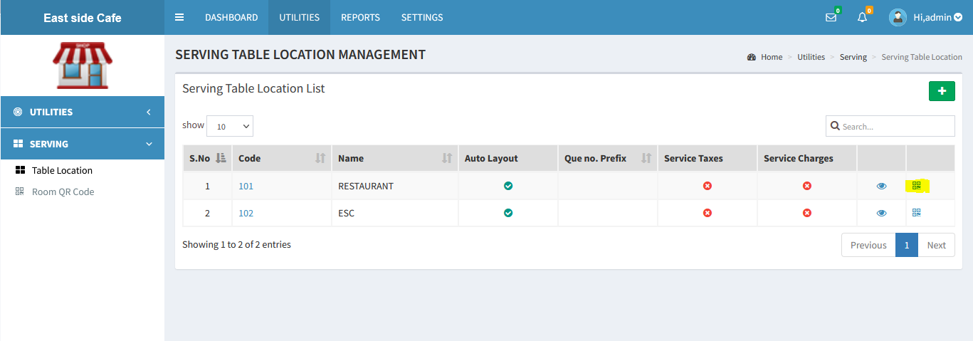

- Print QR Code: A list of QR codes for tables in the selected location will be visible. These may be printed and positioned on the appropriate tables.
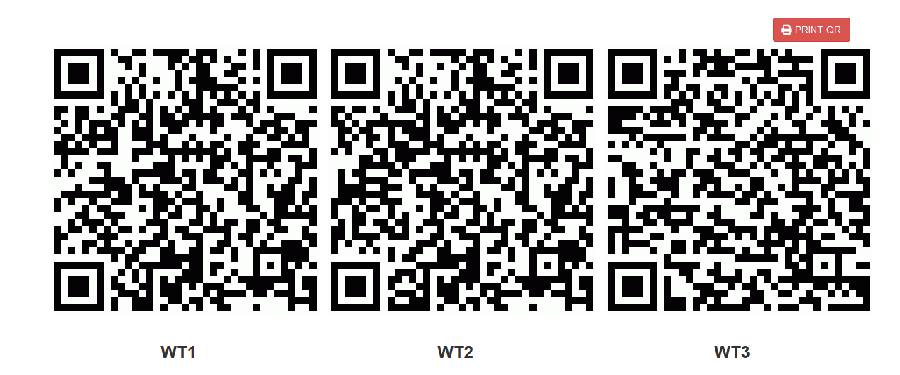

Instruction for Customer

- Scan QR Code: A customer can access the restaurant menu by scanning the QR Code placed on the table with a mobile device / phone.

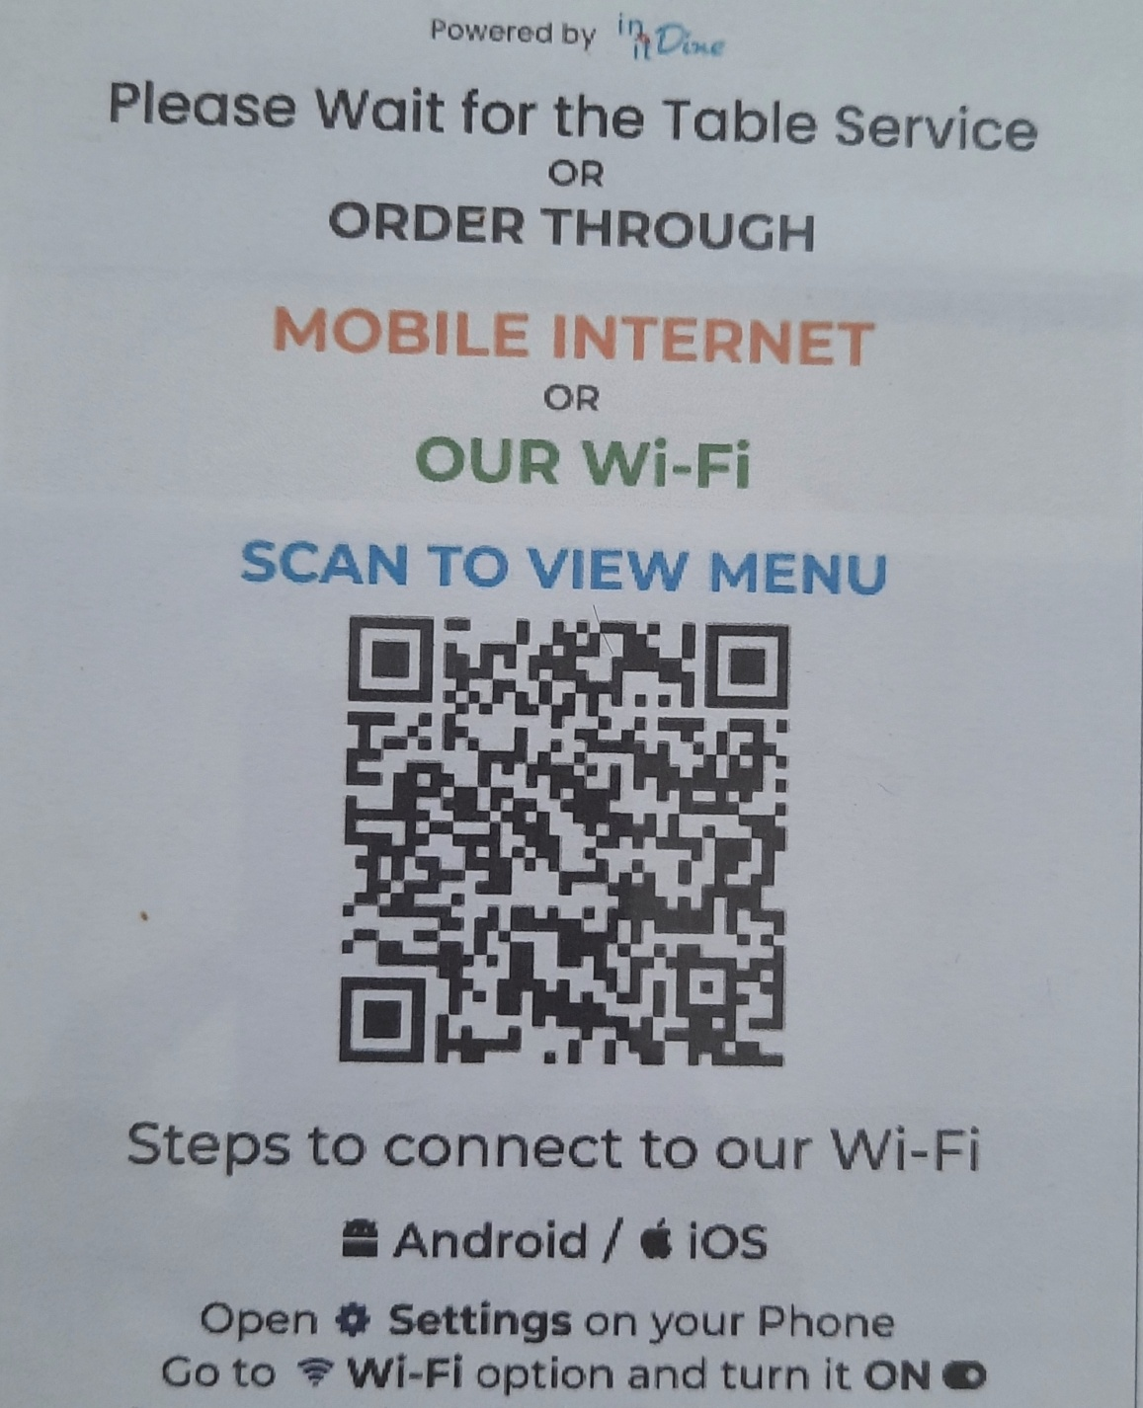

- Access Menu: On scanning the QR code with a mobile device, a customer will be redirected to a web page where h/she needs to specify the name, mobile number and the number of seats needed. Click the ‘Proceed’ button.

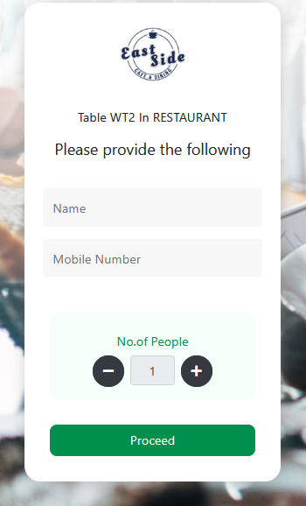

- Browse Menu: A customer is shown the menu where he/she can use a search bar to find a specific item. He also has the option to search through item categories to find an item.

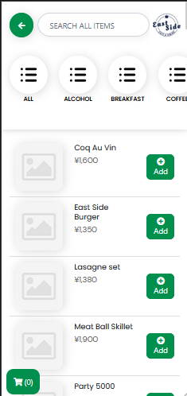

- Add Item to cart: A user can click on the Add button on the item to include in an order. A new window will appear with the details of the selected item where he can increase or decrease the quantity by clicking the ‘+’ & ‘-‘ button. Click the Add button, and optionally any comment for special requests may also be included. This adds the item to the order cart.

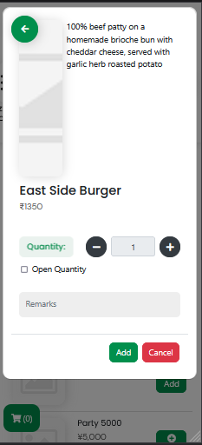

- View Items to Cart: On clicking the cart button, a customer can view the items in the order. A customer may add or remove the item count. He can add new items by clicking the Add button on the top right corner of the app then click the place order button. Clicking the ‘Place Order’ button finalizes the order for the restaurant to process further.

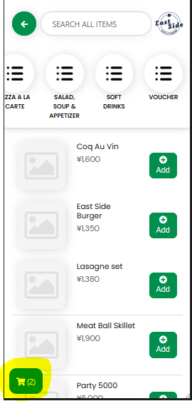
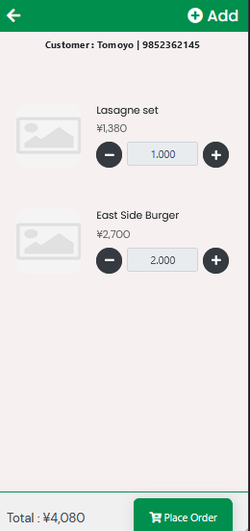

- Edit Order: A customer also has an option to edit an order by clicking the edit button. A remove button becomes available near the ordered item. By clicking the delete button, the item will be removed from the list. Click the place the order button resubmits the order to the restaurant.

Instruction for Restaurant owner / operator

- Approval of Order: After an order is placed by a customer using the QR code based ordering system, the order must be approved by captain[1002]. Only on approval by the captain does the order get sent to the kitchen. A pop as given below appears to get confirmation for the modification.

